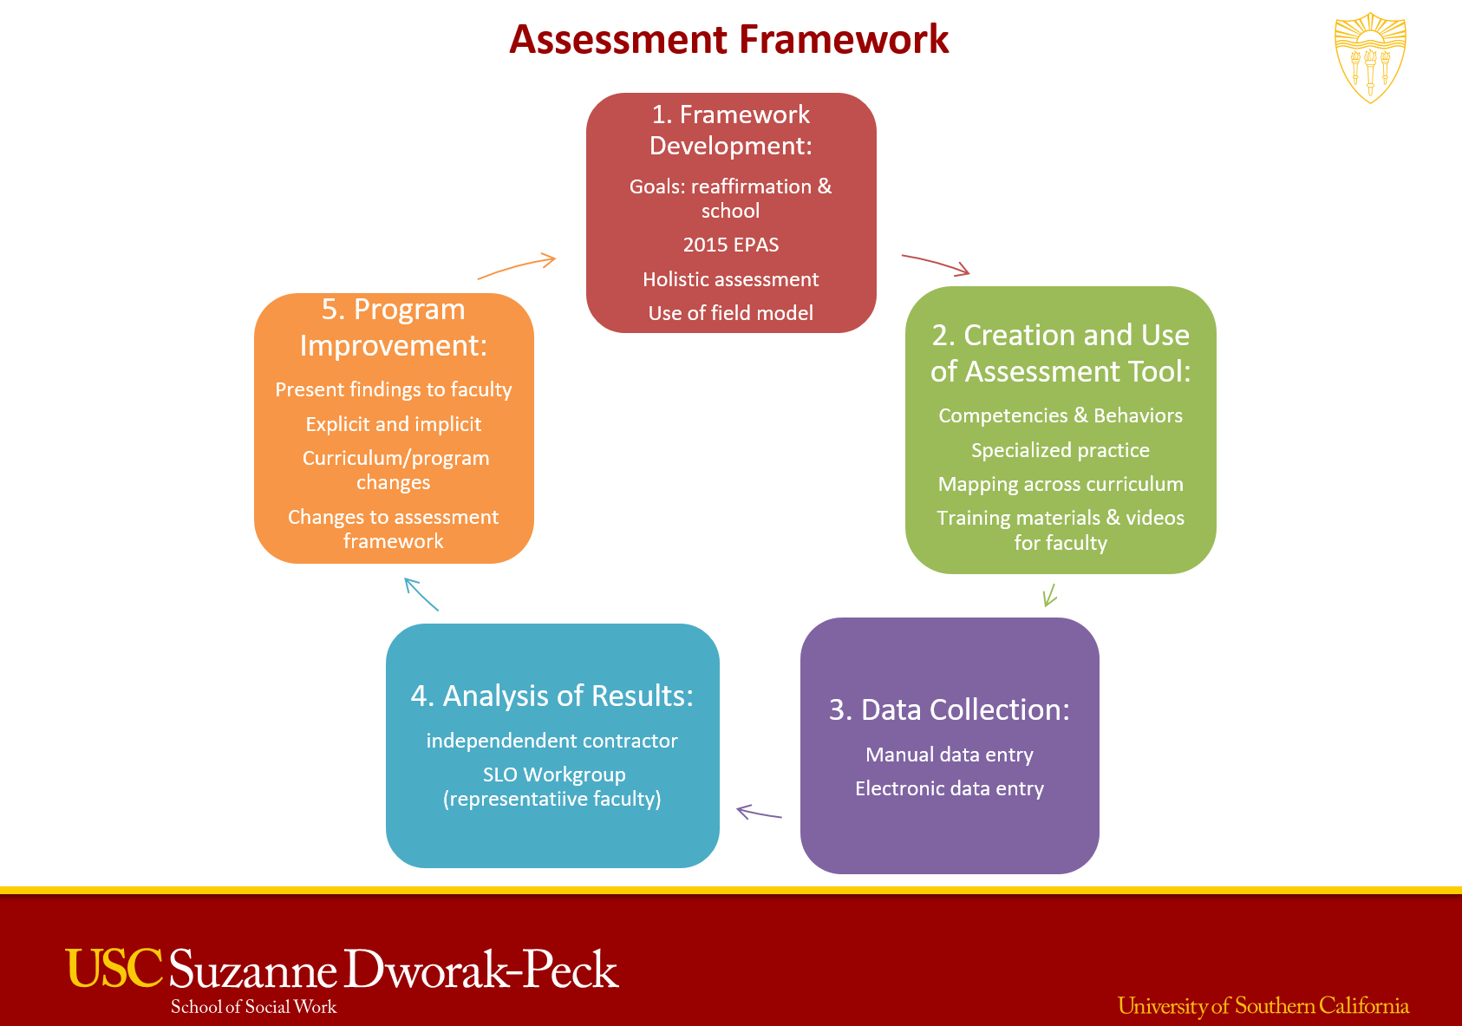

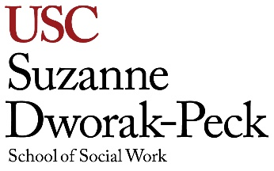

Driving principles underlying design of the assessment framework:

- Assessment over time. Field assessment instrument should enable assessment over time, from first semester through fourth semester, with expectations for level of competency increasing.

- Curriculum assessment should be holistic. Faculty assessment of student competency as demonstrated in classroom should be decoupled from exclusive dependence on grades.

- Faculty should be engaged in assessment process. Faculty members participate in development of framework and instruments, receive training and support to complete assessments, and are involved in discussion of findings and implications for program improvement.

Contacts for more information:

- For questions related to field assessment: Betsy Phillips, Assistant Dean, Faculty Development. email: betsy.phillips@usc.edu

- For questions related to curriculum assessment: Wendy Smith, Associate Dean, Curriculum Planning & Assessment. email: wsmith@usc.edu

- For questions related to electronic assessment system or other technological questions: Rona Smith, Assistant Dean, Academic Affairs. email: ronasmit@usc.edu

