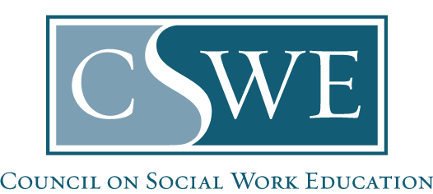

Council on Social Work Education (CSWE)
Board of Accreditation

2015 EPAS
Site Visit Report Template

Instructions: Complete this required Site Visit Report Template and return it to the program’s CSWE accreditation specialist at CSWE within 2 weeks of the visit. Do not alter this template.

1. Program Visited:
2. Program Visited State:
3. Program Visited Level:
4. Date of Site Visit:
5. Site Visitor’s Name:

- Write a brief summary of the general questions discussions pertaining to: Program Mission and Goals (AS 1.0), Diversity (AS 3.0), and Assessment (AS 4.0).

Program Mission and Goals (AS 1.0):
[Summarize your objective/factual findings related to this general question.]

Diversity (AS 3.0):
[Summarize your objective/factual findings related to this general question.]

Assessment (AS 4.0):
[Summarize your objective/factual findings related to this general question.]

- List each accreditation standard/specific question raised by the BOA in its Letter of Instruction (LOI). Provide a thorough discussion of objective/factual findings for each item.

Accreditation Standard…:
[Insert full text of the accreditation standard from the LOI.]

Specific Question:
[Insert full citation language, including the instructions to the visitor, from the LOI.]

Site Visit Findings:
[Write your objective/factual findings to clarify this LOI item.]

[repeat these subheadings for each accreditation standard identified in the LOI]

- Embed a copy of the site visit schedule including the stakeholders with whom the site visitor met.

[Embed here]

