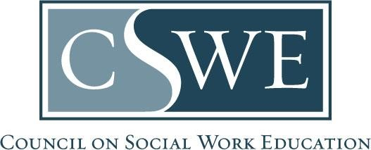

Board of Accreditation (BOA)
Department of Social Work Accreditation (DOSWA)
Baccalaureate and Master’s Social Work Program Accreditation

2022 EPAS
Candidacy Visit Report Template

Directions

Purpose:
- BOA member visitors use this template to report their concerns and consultation.
- Visit the CSWE candidacy process website for a sample candidacy visit schedule, visit policies, and other resources.
- Visit the 2022 EPAS Accreditation Toolkit page for the 2022 EPAS Interpretation Guide and other resources.

Formatting & Submission:
- Do not alter this template.
- Submit this report as a Microsoft Word document, per the Document Submission Policy in the Accreditation Policy Handbook.
- Email this report to the program’s CSWE accreditation specialist identified in the visit assignment.
- The candidacy visit report is due within two weeks of the conclusion of the visit.

Timeframe for Review & Response:
- Candidacy visit reports are reviewed and processed on a rolling basis. CSWE accreditation staff may request clarifying information.
- Upon acceptance of the report, visitors will receive an email confirmation. CSWE accreditation staff then issue the report to the program for a formal response, due within two weeks of receiving the report from CSWE.
- Delayed reports, missing information, incomplete reports, or detached visit schedules may delay processing and affect the program’s accreditation review timetable.

Board of Accreditation (BOA)
Department of Social Work Accreditation (DOSWA)
Baccalaureate and Master’s Social Work Program Accreditation

Candidacy Visit Report

Program Visited:
Program State, District, or Territory:
Program Level: | ☐ Baccalaureate  ☐ Master’s
Visitor Name:
Visit Date: | MM/YYYY
Visit Type: | ☐ Onsite  ☐ Virtual

BOA Visitor Summary

Directions: The visitor summarizes the program’s strengths and areas for continuous improvement. The program responds to the strengths and areas for continuous improvement in the formal program response to this Candidacy Visit Report.

Strengths:

Insert stakeholder experiences and factual observations.

Areas for Continuous Improvement:

Insert stakeholder experiences and factual observations.

Visit Findings | Approval Standards (Benchmark 1 & 2)

Visit Findings | Compliance Standards (Initial Accreditation)

[Delete this help text before submission: Include the applicable heading based upon the current benchmark under review and delete the non-applicable heading]

Directions: The visitor cites concerns. The program responds to each concern listed under the approval/compliance standard heading in the formal program response to this Candidacy Visit Report.

Accreditation Standard

Accreditation Standard #.#.#: Insert full text of accreditation standard.

Concern

Specify what the program provided. Specify what was unclear, incomplete, inadequate, inconsistent, or inaccurate.

The program is asked to… [instruct the program to address the concern].

Repeat for each citation.

Visit Findings | Draft Standards (Benchmark 1 & 2 Visits Only)

[Delete this help text before submission: For Benchmark 3/Initial Accreditation visits, delete the this heading as it is not applicable]

Directions: The visitor provides consultation on the development of draft standards for the next benchmark(s). The program does not respond to the visitor’s consultation in the formal program response to this Candidacy Visit Report. This section is for internal use by the program to strengthen compliance for future benchmark(s).

Accreditation Standard

Accreditation Standard #.#.#: Insert full text of accreditation standard.

Consultation

Specify what the program provided. Specify what was unclear, incomplete, inadequate, inconsistent, or inaccurate.

The program is asked to… [instruct the program to address the concern].

Repeat for each standard.

Candidacy Visit Schedule

Embed here

