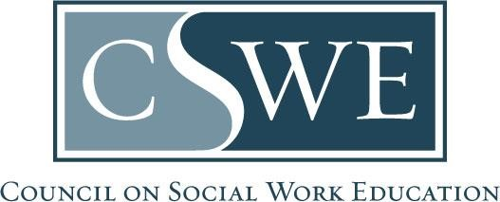

Board of Accreditation (BOA)
Department of Social Work Accreditation (DOSWA)
Baccalaureate, Master’s, and Practice Doctorate Social Work Program Accreditation

Early Submission Notification Form
for Progress Reports and Restoration Reports

Purpose:
Programs complete this form to notify the BOA and DOSWA of their intent to submit a progress report or restoration report earlier than the required date identified in their BOA-issued decision letter.

Formatting & Submission:
- Do not alter this form.
- Submit this form as a Microsoft Word document or searchable PDF per policy 4.7 Document Formatting & Submission Requirements in the Accreditation Policy Handbook.
- A separate form must be completed for each program level (i.e., baccalaureate, master’s, or practice doctorate) requesting to submit a report early.
- Email this form to the program’s CSWE accreditation specialist.
- Submit this form no later than thirty (30) days prior to the document due date for that respective BOA meeting agenda:

Submit this form by November 1st | Progress Report or Restoration Report due by December 1st | Report reviewed at the February BOA meeting
Submit this form by March 1st | Progress Report or Restoration Report due by April 1st | Report reviewed at the June BOA meeting
Submit this form by July 1st | Progress Report or Restoration Report due by August 1st | Report reviewed at the October BOA meeting

Timeframe for Review & Response:
- Forms are reviewed and processed within 30-days of receipt. CSWE accreditation staff may request clarifying information.
- Missing information or incomplete documents may delay processing and affect the review process.
- Programs receive an email explaining the outcome of the review.

Date Submitted to the CSWE DOSWA: | MM/DD/YYYY

Program Information

Name of Educational Institution:
Program State, District, or Territory:
Program Level:  Check one only | ☐ Baccalaureate  ☐ Master’s  ☐ Practice Doctorate
Next Accreditation Review Date for Report:  Must match CSWE records; review Directory of Accredited Programs for accuracy. This information can also be found within the program’s BOA-issued decision letter. | Month/Year
Earlier Agenda Requested:  Check one only | ☐ February YYYY BOA Meeting (report due December 1st)  ☐ June YYYY BOA Meeting (report due April 1st)  ☐ October YYYY BOA Meeting (report due August 1st)
Next Accreditation Review Type: | ☐ First Progress Report  ☐ Second Progress Report  ☐ Restoration Report
Standards:  Accreditation standards the program is currently operating under for this report | ☐ 2015 EPAS  ☐ 2022 EPAS  ☐ 2025 Standards for Practice Doctorate Programs  ☐ 2020 Pilot Standards Practice Doctorate Programs

Form Authorization

Social Work Program’s Primary Contact

Check this box:
☐ As the social work program’s primary contact, I hereby support and authorize the early submission of our materials. We agree to submit earlier than required, be held to that earlier date, and not revert to the original due date.

Primary Contact  Signature: | Insert e-signature or image of signature
Primary Contact
Name, Credentials:
Title:
Date Signed: | MM/DD/YYYY
Phone #: | (###) ###-####
Email Address:

The primary contact’s role is described in the Accreditation Policy Handbook. The primary contact manages all accreditation-related communications between the program and CSWE.

