Experiences of Social Work Students, Faculty, and Staff with Disabilities
Photovoice-inspired Project
Funded by CSWE Special Projects Fund
Submission 1

I identify as a social work student with disabilities and wanted to create a picture that includes the things I use on a daily basis to manage my symptoms.

Here's a list of the things I included in the picture: two therapy workbooks, various supplements, prescription medications, a heating pad and blanket, a weighted blanket, hand sanitizer, pill organizer, fidget cube, a massage gun, a small massager you put on your hand, a small tin with dab pen with CBD and THC carts, a marijuana edible, a marujuana grinder, Epsom salts, a jade roller, turmeric, and a lavender essential oil roller.

I placed all these things on my bed because it's where I feel most comfortable and where it feels like my disability symptoms are less intense. I just wanted to show the amount of things I need to use on a daily basis to manage my disability symptoms. Forgetting to use just one thing can throw my symptom management off and I have a more difficult time going about my day. Also it's super expensive to buy all these things, and difficult to remember to take/use all of them.

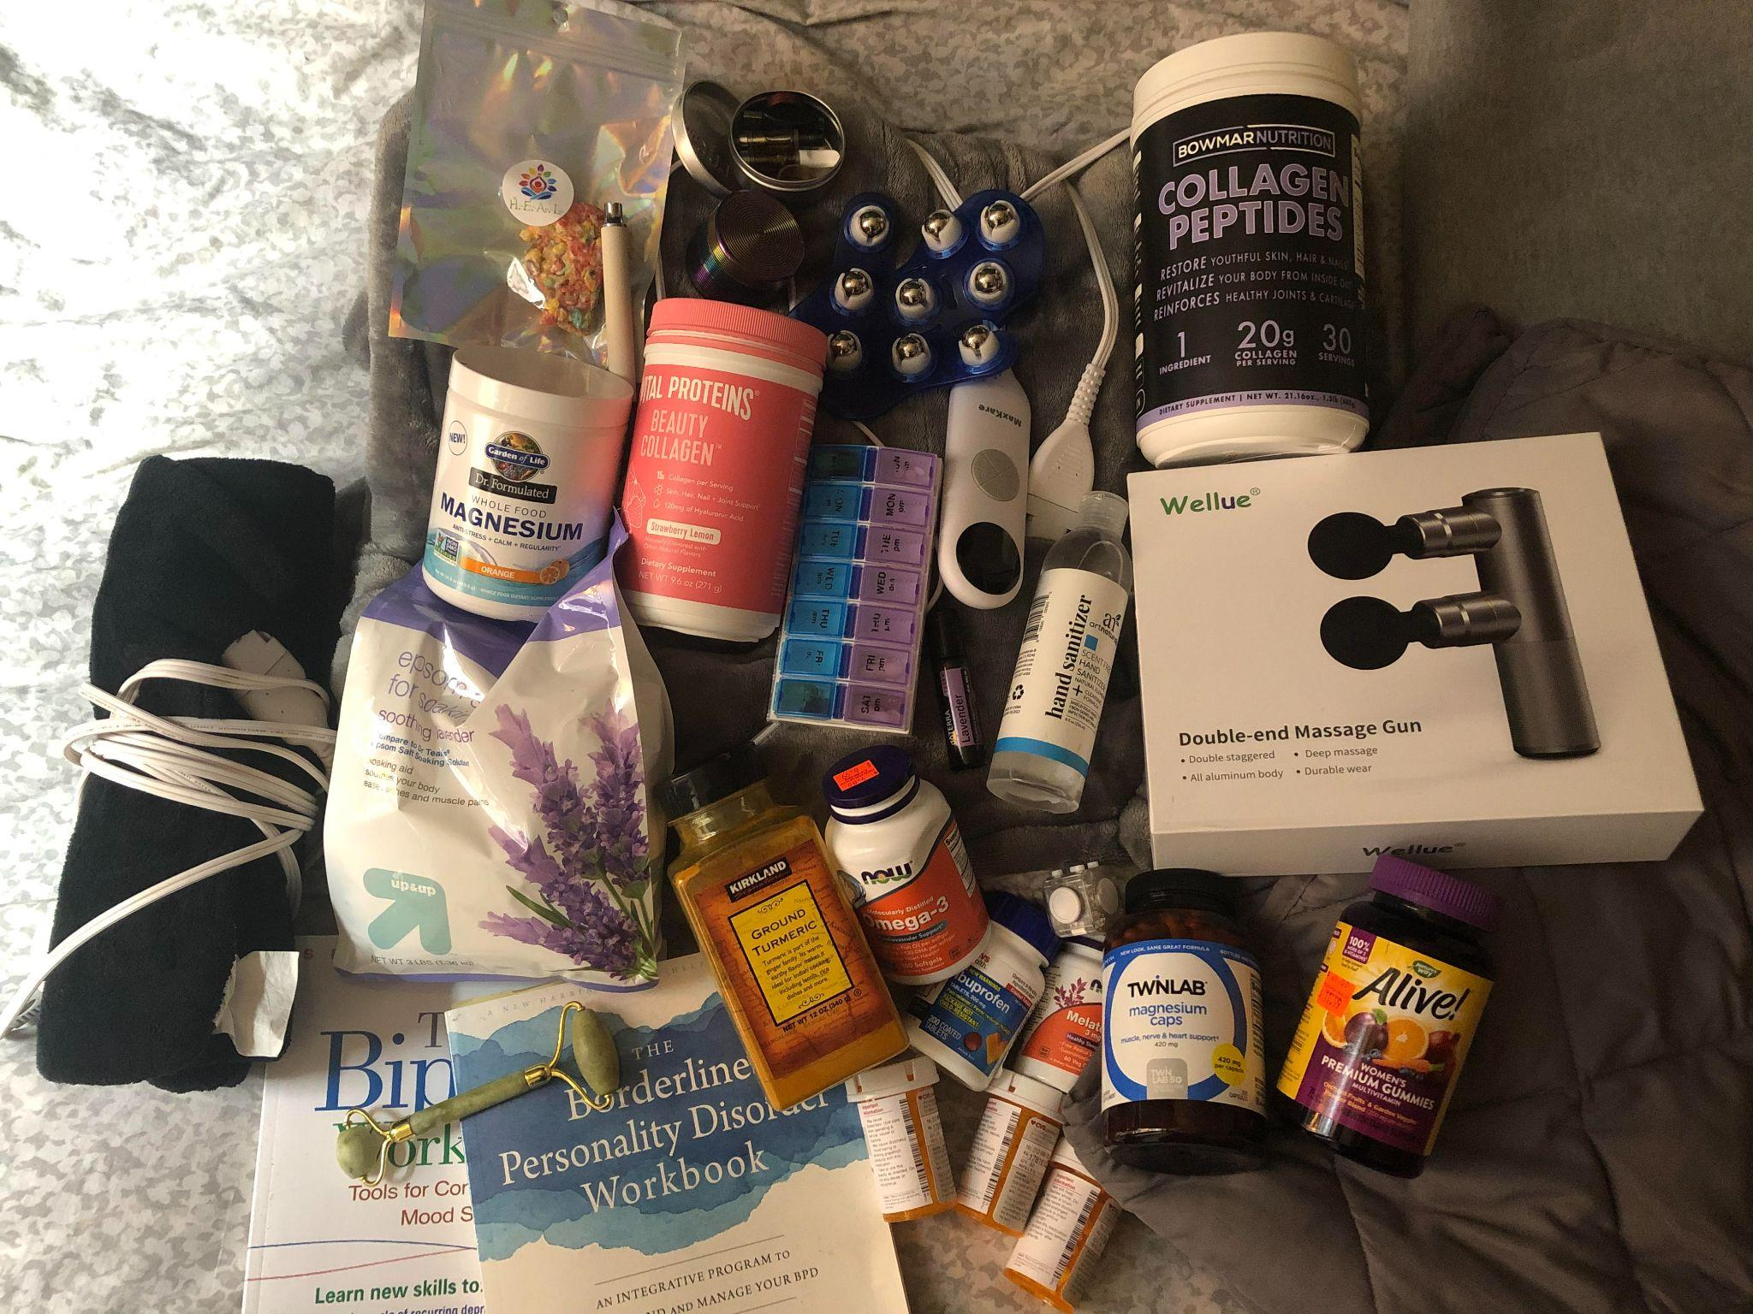

Submission 2

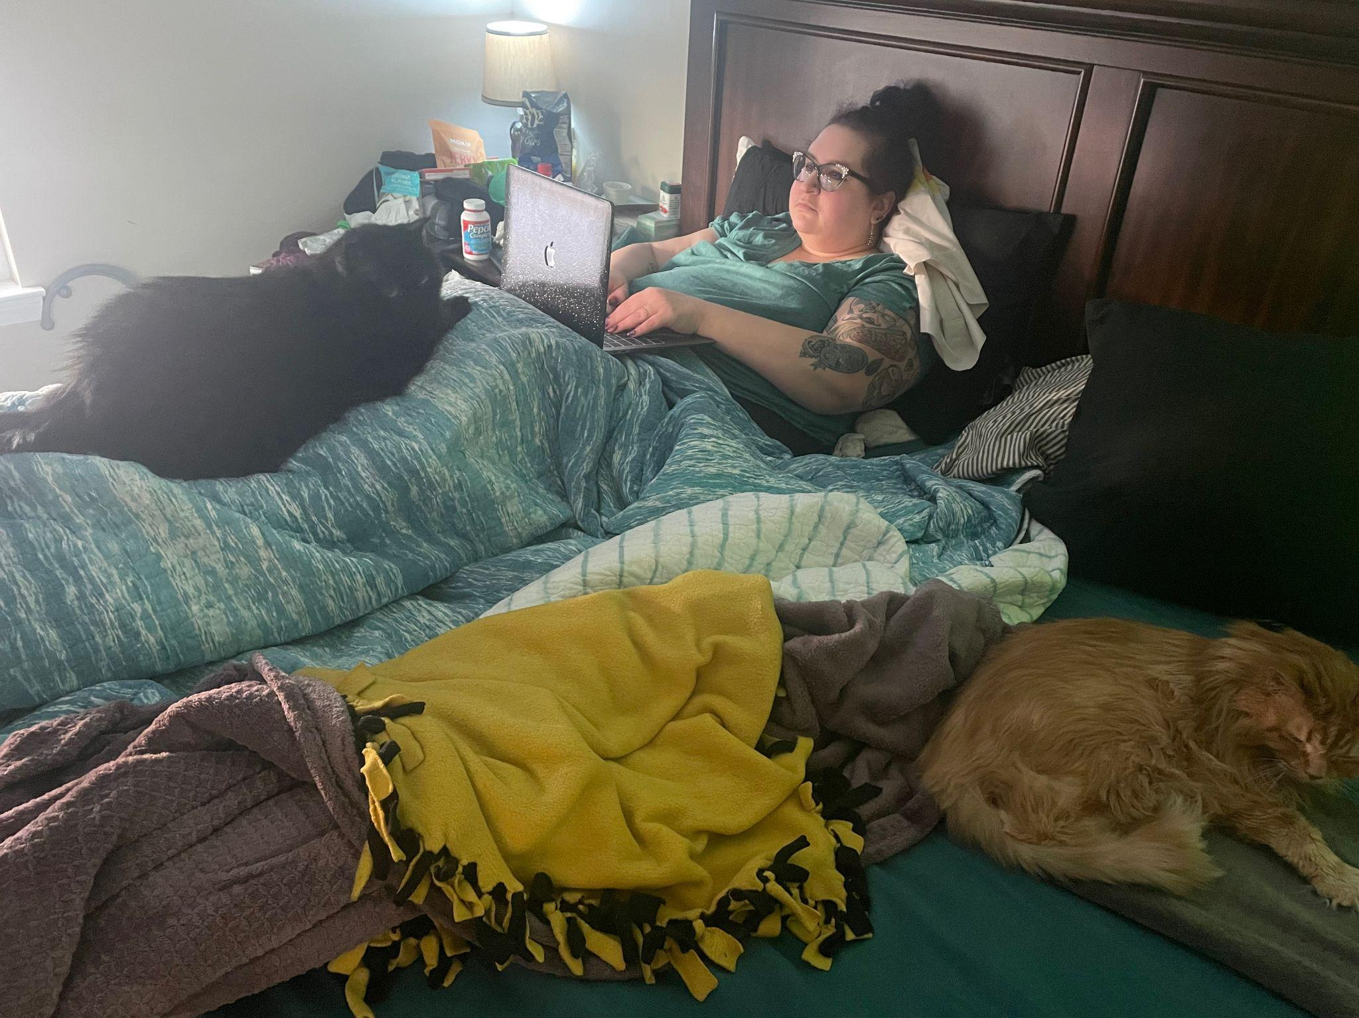

Submission 3
Birth of an Article
By Shanna K. Kattari
I spend a lot of time in bed and on the couch; feet elevated so I don’t pass out, heating pads on my back and hips to ease the pain, ice pack at the base of my skull to try and keep my migraines at bay, a table of medications, snacks, and assorted drinks to keep hydrated beside me.
If you know, you know.
I remember the day I first gave myself permission to teach while sitting, instead of standing and walking around with my cane. It felt so weird; I had never had a teacher who sat, yet this put me on the same level as my students. It was oddly powerful. We often speak about the power differentials in education settings, but something as simple as encouraging people to be at the same level as those we teach has rarely been named. I have not stood up to teach since.
I remember the day I first gave myself permission to take a virtual call from bed, instead of moving my body, my heating pads, my ice packs, my meds, my snacks, my liquids to my fancy looking office with proper lighting. Yet, as much as I was anxious about not looking professional (really, what is professional?), no one said a word. The world didn’t end. The meeting went on as it was supposed to.
I remember the first day I taught a class from bed apologizing to my students. I will never forget their responses. One asked “Dr. K, would you ever judge us for learning from bed?” while another quoted myself back to me, saying “Show up how you can, when you can, and whatever that looks like is enough.” We are our own worst critics, though an Academy steeped with ableism and white supremacist, cis het patriarchal, and ableist norms of professionalism seek to undermine us at every term.
Working ourselves to death, to exhaustion, even “just” to pain and burn out is NOT professionalism. It’s capitalism.
So here I am, working from bed, writing a journal article. My neurodivergent brain simply cannot do the “30 minutes of writing a day” bullshit we have all been sold. Rather, when I have inspiration AND capacity, I will sit down with my computer and write the draft of an article, a new study, an innovative assignment, all in one go, sometimes not leaving my bed for 5, 6, 7 hours at a time. That is what works for me. This is what productive means TO ME.
As I lie in bed, two of my academicats keep me company while I envision and create…legs elevated, heating pads around my back and hips, ice pack at the base of my neck, meds and snack, and drinks next to me.
And in this snapshot of time, an article is born.
Submission 4
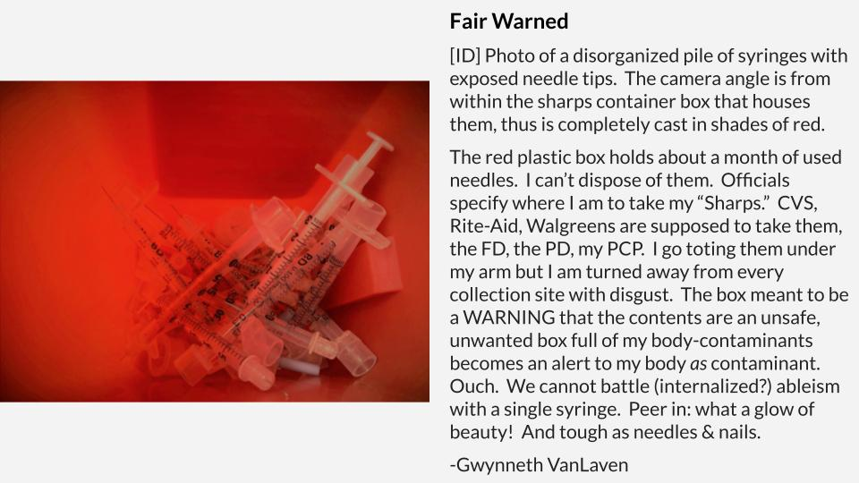
Submission 5
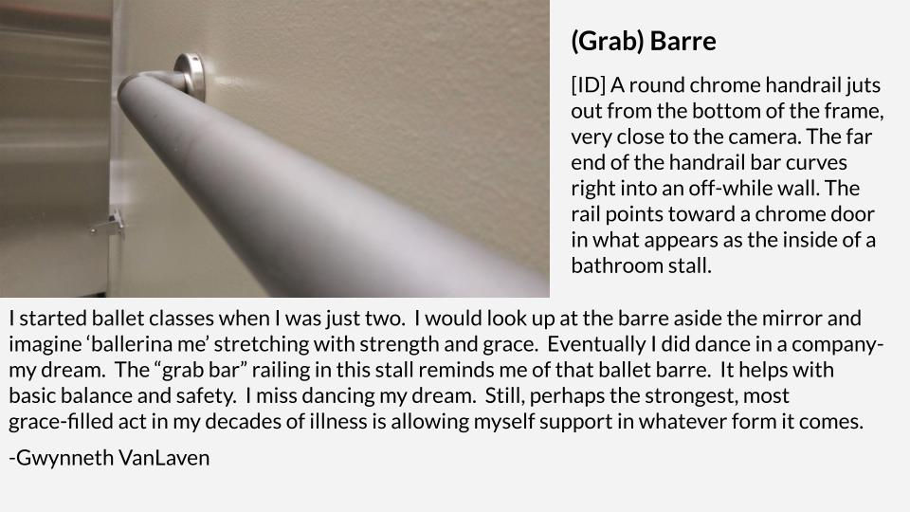
Submission 6
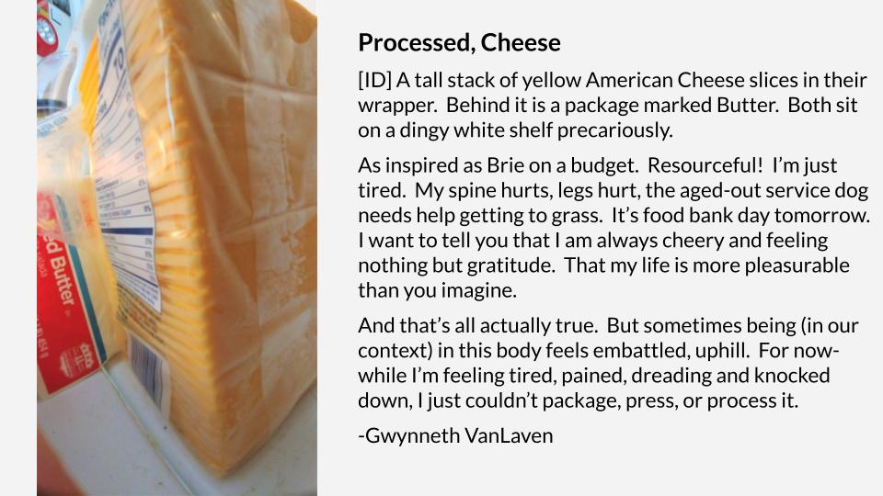
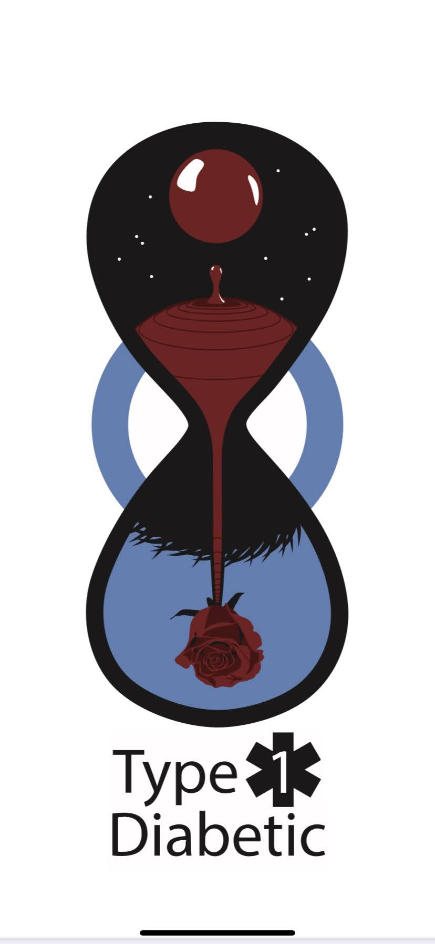
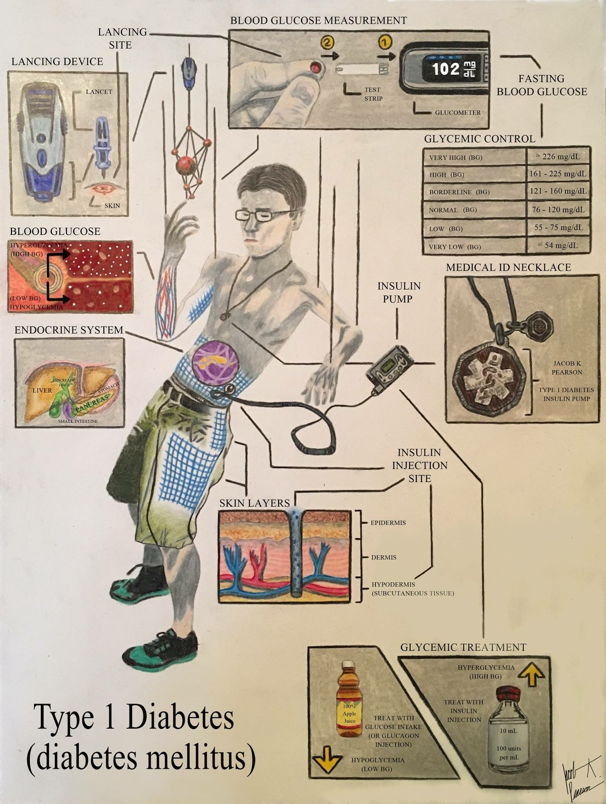
Submission 7
Submission 8
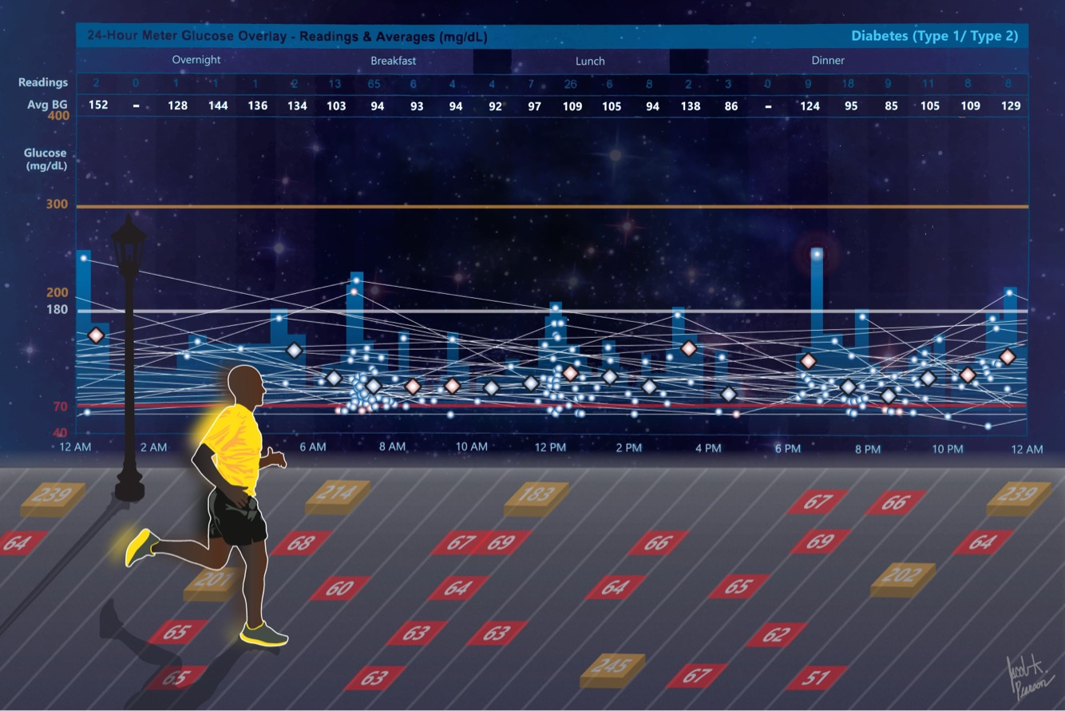
“My name is Jacob K. Pearson, and I am a Master of Social Work student at the Brown School at Washington University. I have been a type 1 diabetic for a little over 10 years.

When I was diagnosed with diabetes, I was told, ‘Here’s an orange and a syringe. You can practice injecting insulin into the orange before you stick your own body.’ This is how I learned diabetes management, and it was a learning curve. I felt so alone, but I eventually learned I was not.

Diabetes started out as something I wish I could get rid of, something I was embarrassed by, and something I wanted nothing to do with. Throughout this 10-year-long learning curve, however, diabetes has become something I love about myself. Diabetes has become an identity, a guiding principle for what I do and who I am each day, and a reason to live each day fully. Diabetes has become for me a beautiful struggle and a community. I have learned from those around me – my older brother, who passed away from cystic fibrosis; my dad, who is also a type 1 diabetic; and my wife, who lives with muscular dystrophy – that life is beautiful because of the challenges we face, not in spite of them. As a diabetic, I have dignity – not in spite of the synthetic insulin floats in my blood – but because of it.”

Submission 9
Ode to Academic Ableism
By a really disheartened junior faculty member
Even the most basic access has always been too much for most non-disabled faculty. Constantly pushing back against doing the bare minimum.
For years…
“No, I can’t hear you without a mic…Yes, even if you’re loud.”
Just. Use. The. Mic.
No, I’m not going to explain myself.
Again.
Again.
Again.
Second guessing myself in
every faculty meeting
every committee meeting
every senate assembly meeting
Am I being too direct? Not direct enough?
*Letter in my academic file about my communication style*
You don’t know how to communicate. You make people uncomfortable. You’re too aggressive. You’re too much.
[Despite years of evals from students saying the opposite]
[Despite my close colleagues and accomplices saying I communicate boldly] [Despite winning awards across teaching and scholarship]
Autistic folks not welcome here.
The letter doesn’t say this in so many words, but it screams in my brain. You don’t know how to communicate.
My OCD intrusive thoughts chime in.
You’re not supposed to be here.
It’s an accident you were hired.
They are going to figure it out.
You’ll never get tenure.
Why don’t you just die? It would make things easier for everyone.
Rejection sensitive dysphoria is a bitch.
I AM supposed to be here, even if you don’t think so.
Even if the Academy isn’t made for people like me.
Pandemic hits.
Everyone else is struggling with the transition to online, and for the most part, I am thriving.
Not having to make direct eye contact
Being able to have captions and a live transcript of all meetings
Teaching from a comfortable chair, with my legs up, ice pack and heating pad in use Using fidget toys to stim without being stared at
Ability to turn my camera off if I am overwhelmed
The pandemic has made my life as a faculty member so much more accessible than ever before.
I am so afraid of losing all of this access when we go back “to normal.” What even is normal?
Normal meant ableism at every turn. I’d rather not go back.
“Excuse me, but could someone please turn the captions on?”
Why is this so hard? It’s just a button.
I feel for my Deaf colleagues who have had this struggle for decades, in the name of it being too difficult to have CART or ASL interpreters at daily meetings. Something is now easily available and yet people don’t use it.
Guess you didn’t REALLY mean that it was too complicated – you just didn’t care. Your excuses are now invalid.
Like me, an Invalid Invalid.
“Could you please add image descriptions? Really, it’s just describing the image.” Again, such a simple concept, and yet so rarely done.
More inaccessible PDFs sent on the list serve, more copies of
copies of
copies of
copies of
articles assigned to be read.
“Is this gluten free? Please don’t just guess; I have celiac, and it will make me sick. I appreciate this event has food, but if it isn’t safe for me, I’ll need to bring my own meals. I just need to know.”
No one seems to know.
No one knows how to get the answer.
It’s the 2020s. Why are we not labeling food? I cannot be the only one.
On the job market, I was told to carry almonds in my pocket in case they served me food I couldn’t eat.
Almonds. In. My. Pocket.
My dress didn’t have pockets.
My dress was not viewed as professional.
Why couldn’t I just wear a suit?
My dresses are a self-selected accommodation. They allow me to maneuver through sensory issues and reduce issues of chronic pain and fatigue.
My accommodation is not professional.
Am I not professional?
*Talks held in a space where you have to take stairs to present*
I see I am not welcome here.
I am told there are accessible seats, at the back of the auditorium. I am supposed to present, to speak, to educate.
The spaces that are designed for my body are the ones for students, for attendees.
Professors, lecturers, presenters – we are not supposed to be disabled. No space for disabled bodyminds at the front of THIS room.
I am not supposed to be here.
I limp my body down the stairs to present, every step another stab of pain. What a choice to have to make.
*Eye roll every time I bring up accessibility*
Accessibility isn’t an option. It’s a legal mandate.
As social workers, it is an ethical mandate.
As humans, it is a compassionate mandate.
Accessibility is a basic right.
Accessibility is a human right.
How dare you roll your eyes as I/we advocate for students, for staff, for faculty, for our clients, for our communities.
“Hi, I’m your professor for this class. You should know that I am disabled, chronically ill, and neurodivergent. What this means is…”
Being open with my students about all of my identities and my disabled bodymind has deepened our connection in ways I cannot put to paper.
Students come out to me.
They come to my office…
for the tea
for the chocolate
for the dim lights
for the body friendly chairs
for the fidget toys
for the stuffies
for the affirmation that being disabled is an ingenious way to live
for the reminder that they are not too much
for the feeling that they belong here
They disclose their own disabilities, illnesses, questions, anxieties
They ask me to reach out to their faculty:
♦ “Can you ask them to not require us to stand while we present?”
♦ “Can you help them make this activity more inclusive?”
♦ “Can you see if they’ll let me eat during class, even though it is against their rules?” ♦ “Can you get them to let me have my laptop, even though they have a laptop ban?” ♦ “Can you remind them why some of us can’t have our cameras on during class?”
My answer is always yes.
I am here for the students.
I am here to serve them.
Even as my own access needs are challenged, I won’t stop trying for them. Yet this doesn’t count as service.
*Diversity, Equity, and Inclusion [but excludes disability]*
Every time. Every institution.
Show me your strategic plans, your
5-year
10-year
20-year
plans
How many include disability at all?
How many include disability cultural centers? Groups for disabled folks to gather? Recruiting disabled faculty? Retaining disabled faculty?
Funding disability research by disabled people?
Meeting ADA isn’t inclusion – it is basic access.
Disability IS diversity.
Disability justice is equity work.
Disability inclusion goes far beyond accommodation and accessible parking.
Let us move away from deficit-based models of learning and towards universal design. Let us move away from a focus on independence and towards interdependence. Let us move away from disability as a “problem” and towards disability justice.
Let us move towards our values.
We must do better; for our students, for our staff, for ourselves.
Submission 10
Once upon a time there was a human.
The specifics don’t matter—They do! They don’t. Do they though?
A student, teacher, teacher, student.
Engage, assess, intervene, contravene, convene
Courage, carriage, career [fear]. Consider:
Disability, Dis-ability, Ability, Abrogate, Debilitate, relate
Do [did] I teach you [taught you] show you the pain—My pain, Their pain, Our pain.
The pain, the pane, the stain, the stare [stair]
The world tears [tears].
If only my hands could hold high here.
[hurts hurting hurt helping hurts] The pain.
Do you notice the pain?

Haylee Hebenstreit
doctoral student, social justice/policy adjunct faculty
[I consent to the inclusion of this identifying info with submission. Best of luck in your research--a great topic & sorely needed!]
Submission 11
Who knew that such a mundane task could be so debilitating?
Everyone enjoys eating- everyone except me.
Missed classes, races to the restroom, chronic pain, fear and anxiety-
That wasn’t supposed to be my college experience.

I came here to help others, but I ended up needing so much help along the way.
Long bouts of testing, different doctors with new diagnoses-
But no answers.
My upperclassmen years were spent in misery.

Through a global pandemic it was even harder to find help for a chronic condition with no name.
With hospitals overwhelmed with the virus, other problems seemed to take a backseat.
And so I waited.
And waited.
And I hoped that the newest medicine would work, but it never did.
More tests. More medical bills.
This was not supposed to be my senior year of college.

People always say failure is hard to digest,
But for me so is everything else.
Keeping my grades up meant doing classwork whenever I wasn’t crying in my bathroom
Wishing I could rip out my insides just to feel some relief.
While friends went out on weekends, partying and enjoying their free time
I was catching up on lectures I missed, racing to finish projects while I had a brief moment of relief.
No one else’s college experience was like this- why was mine?

As the virus started to slow down, I found hope-
A new diagnosis.
A new doctor with a new perspective.
One who believed my story and listened to my concerns as I cried in her office.
21 years old, but I felt decades older.
So here we are- a name for the pain I’ve been through.
Correct medication to help me get through the day,
Holistic methods to help fight the fear and anxiety that comes along with the disorder.
I will never escape this plague that has ravaged my body and stolen this time from me
But I now have the strength to face it
And the ability to finish my college experience the way I wished I’d spent the last four years.
It’s my turn to help others, now that I’ve finally helped myself.
My college years weren’t supposed to be like this-
But maybe now I can enjoy what I have left
And look forward to a brighter future.
Submission 12
Hi my name is Maranda Thomas, and I am a senior at Spalding University currently working getting my bachelors degree in Social Work. I currently play softball for Spalding University and I will be hopefully graduating June 2022. Throughout my experience at Spalding, I have learned that my disability is something really affected me. I was diagnosed with severe anxiety, which led me not to talk in front of people in class, it has led me to really procrastinate but still get things done on time and it has made me feel like I as slower at getting things done compared to other people. Starting out as a freshman I was a transfer from Indiana University Southeast. I hadn’t done the best there so I had to find a different school that was a better fit for me which ended up being Spalding. Before I got into Spalding, I had to write a letter on how I be a good fit, and how I would excel here. Once freshman year ended, I found myself trying to reach out to my professors but it was just a little hard because I didn’t really know anyone and I was still learning my way around the campus. I didn’t really know what I wanted to major in either by the time freshman year had ended so with my anxiety and feeling like I had to have something picked I just picked something but it wasn’t what I wanted to do.
Sophomore year came around and I found myself trying to gain more confidence. I also found myself going through a breakup and trying to figure out how to maintain my grades. I ended up getting help at the counseling center for my anxiety and trying to really push myself but it was just hard. I couldn’t really seem to get happy going to the counseling center so I just quit and tried to focus on myself. Sophomore year not a lot of things happened but I felt as if I was continuing getting better and my grades were getting better. By the end of sophomore year, I finally chose to get my bachelors in social work but I didn’t know what kind of job I wanted to do.
I felt as if junior year started affecting my anxiety because of COVD and having to move online was defiantly harder then I imagined it would be. I found myself struggling and asking my professors for help on different assignments. This was the time I had started most of my Social Work classes, I knew they be hard but I knew if they were in person, I probably wouldn’t have struggled so much versus being online. I think being online affected my mental state because I was worrying about always having my computer charged, trying to talk in class and showing myself. With my anxiety it was hard junior year being on zoom just because I was so scared to talk in front of others, I was scared to show my self on camera because it just wasn’t the same as being in person.
Its my senior year and with being in person I feel like I am doing better but I am also finding myself struggling a little bit more just because the classes seem to be a bit harder. I have found myself speaking up more in class around my peers which was something I had struggled with by having anxiety. I have also found myself talking and reaching out to my professors more now as well. I use to be so afraid to ask my professors for help but now I know they are there for me I am finding myself more comfortable. I also am finding myself more comfortable and not anxious to speak around my peers in class since I have been around them since Junior year.
All in all, I feel as if my anxiety has put a toll on my education but it has also made me more motivated to want to reach my goals and graduate since I will be the first college graduate in my family. I have learned even though I have a disability I am still the same as everyone else, but I shouldn’t be ashamed of my disability. I have always been afraid to let people know about my disability and how it has affected me but I feel like Spalding has really helped, my professors have been helpful, my peers in my social work cohort have been helpful as well as my softball coaches and teammates. If it wasn’t for Spalding, I don’t think I would have found a college that is very helpful with people who have a disability and the scheduling of classes made it very helpful as well.

Below I have added some photos of the things that have made me struggle and the things that have helped me.
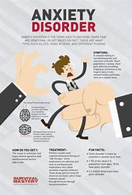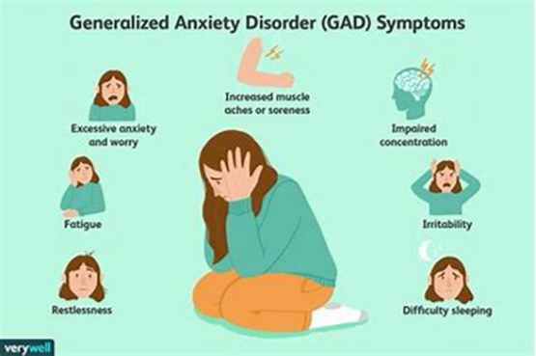
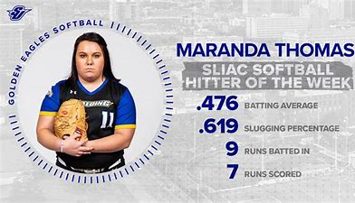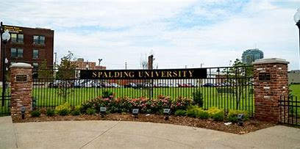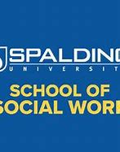
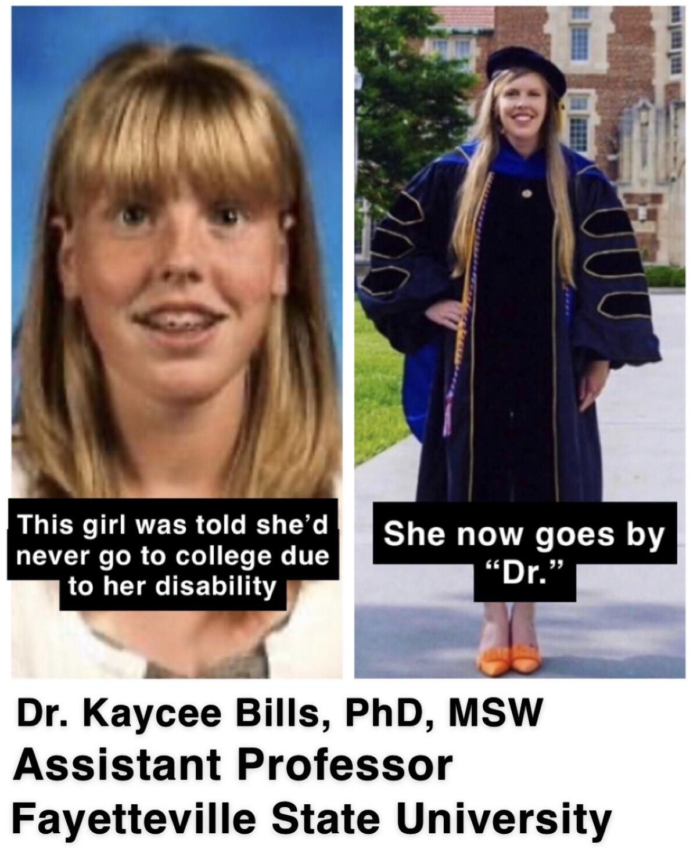
Submission 13
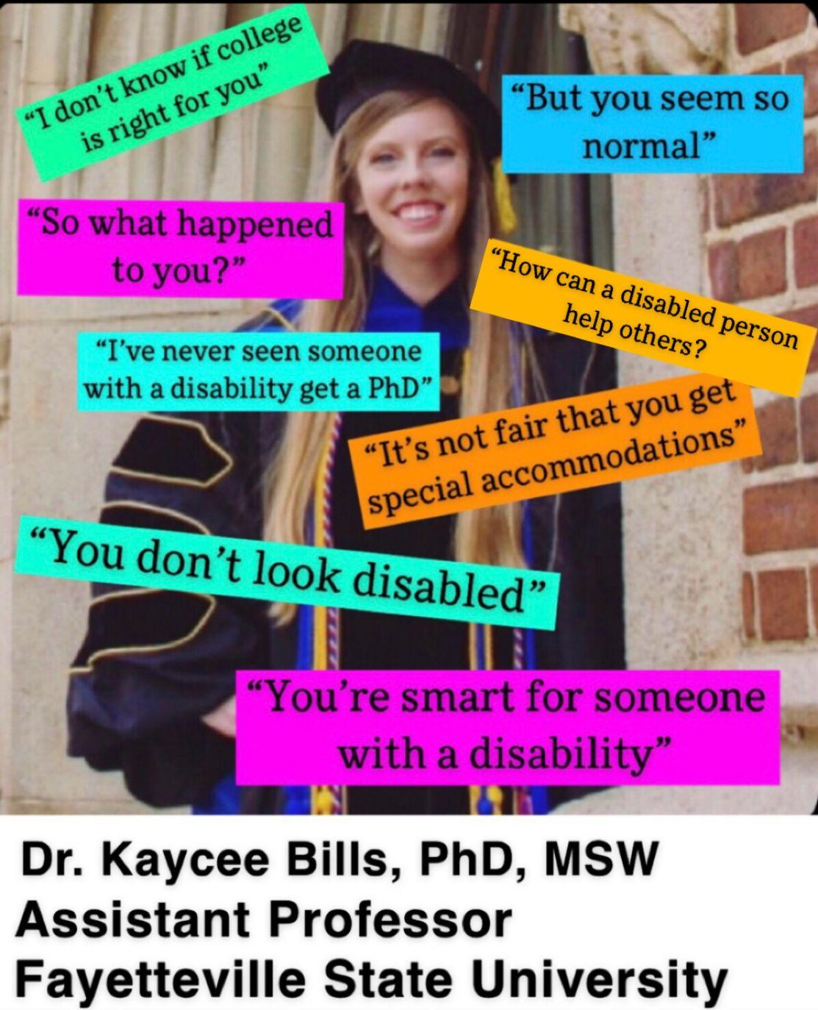

Submission 14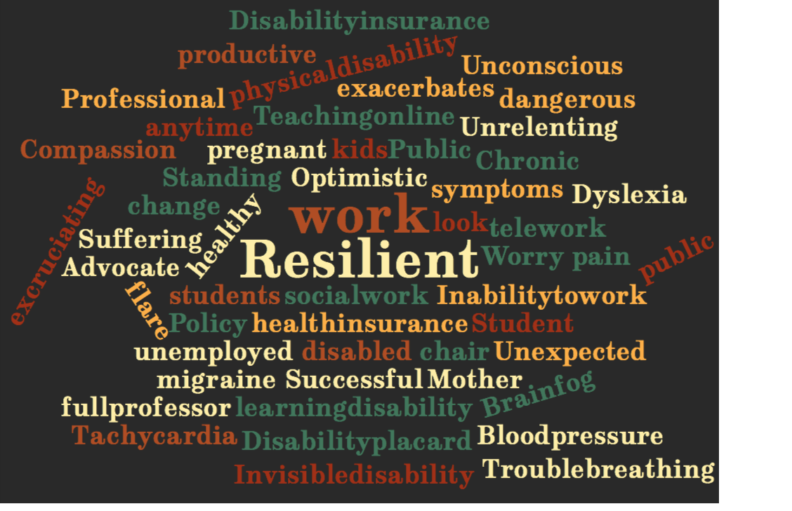
Submission 15
Sarah is a social work student at Stony Brook University. Her disability is she has OCD (Obsessive-Compulsive Disorder). She checks her work several times before she submits it, even for texts to friends! Unfortunately, this is very time consuming. Sarah knows that logically, it’s not necessary to check her work more than once, but she cannot stop herself from checking it more than one time, even though she has been in psychotherapy and on medication for years to try to substantially minimize her OCD. Thus, she wanted to apply to an MSW program if her OCD ever became close to zero.
Not to insult social work at all, but Sarah realized that accuracy in social work was not as crucial as in pharmacy, which she shamefully flunked in college 14 years ago. Hence, she decided to finally apply to the MSW program at Stony Brook University, which miraculously accepted her in Spring 2021!! Sarah loved her professors because they were insightful and kind! She grew to become more comfortable voicing her thoughts during class! She still checked her work and emails to professors and classmates several times before she submitted them, which took up a lot of time. However, at the end of her first semester of grad school in Fall 2021, Sarah shockingly earned excellent overall grades for all of her classes!! Therefore, although her disability made her life as a social work student difficult, she was still able to perform well in her social work program thus far. Hopefully, her recent success will convince her to decrease the number of times she checks her work before she submits it!
Sarah likes her university campus. Out of her own volition, she attended 3 different bystander intervention trainings through her school’s Center for Prevention and Outreach. Thus, she will receive the Upstander Award! Sarah also voluntarily attended a variety of workshops through this center, such as learning what rape culture is and how to avoid getting the flu. More than once, she checked her responses on the registration form for all of these trainings and
workshops before she submitted this form, which took up more time than necessary. Even with her annoying OCD, she plans to attend more workshops in Spring 2022, which will enable her to earn various certificates. Hopefully, earning the Upstander Award will persuade Sarah to reduce
how many times she checks her responses before she submits them! Taking into account her disability, her overall personal experience on her university campus has been positive!

Submission 16
TICCING

Before a meeting, preparing to drive, or ruminating on bills,
I feel trapped, caught. Something’s not right.
Something’s constraining me. How can I wriggle free?

Open eyes wide, blink. Nose twitch, nose twitch. Flare nostrils, flatten lips.
Grind teeth, roll jaw, shimmy shoulders, stretch neck.

Hereditary. An aunt purred, threw imaginary salt over her shoulders
While Grandpa played his invisible cornet.

Unsightly. Odd to others. I must put them at ease while I am not.

Hide the moves. Cloak them in a gesture of mundane.
Maybe I am stretching. Or looking at the sky.
Checking my blind spot, but not too long, too far.
Not attenuated, exaggerated, grotesque.

I’ll wait for a private place: A cubicle, bathroom, hallway
Where I can get right with myself.

Open eyes wide, blink. Nose twitch, nose twitch. Flare nostrils, flatten lips.
Grind teeth, roll jaw, shimmy shoulders, stretch neck.

Sisters and brothers, I see you.
On the train, or at a film.
You stretch, reach, look around, feigning motives:
Dust in your eye, an itchy scarf.

We are too much for this world.

Could there be a place where our moves are not too long, too far,
Attenuated, exaggerated, grotesque?
Where your moves are rich, mine complex?

You’ll see me under the disco ball.
I’ll see you in a spotlight on the ice
Nailing salchows and axels of your own design.

Meanwhile, inside my shoes in luscious privacy
My toes tic constantly, dreaming of liberty.

–Janet Young, Columbia School of Social Work (Staff) jy2994@columbia.edu
Submission 17
As a first-generation college student graduating from Fayetteville State University, Adrianna decided to major in social work and minor in public administration. Adrianna has dealt with her challenges with a learning disability. Even before entering FSU, she advocated for students’ disability rights. She served as a GEAR UP Program volunteer assistant and a GEAR UP tutor in the Cumberland Country School system. While on campus, Ms. Fields became a member of the Phi Alpha National Social Worker Honor Society and the Omega Beta Chapter of Zeta Phi Beta Sorority, Inc. While a Ronald E. McNair Scholar, she co-led a research project with her mentor, Dr. Kaycee L. Bills, on the Disability Community: A Systematic Review of Biological and Environmental Impacts on Learning Disabilities and Graduating Rates. As she continues to challenge herself, Adrianna has set her next academic goal to earn a master’s degree in Social Work, ultimately leading to a Ph.D. in Social Work with a disability studies concentration. To further her ability to be an advocate and champion of those with disabilities, Adrianna intends to earn her American Sign Language Certificate, become a Licensed Rehabilitation Counselor, and obtain her Community College Teaching Certificate. One of her career aims is to work for the U.S. Department of Education to create impactful programs that will give those with disabilities access and lead to student success as they matriculate into higher education and beyond.
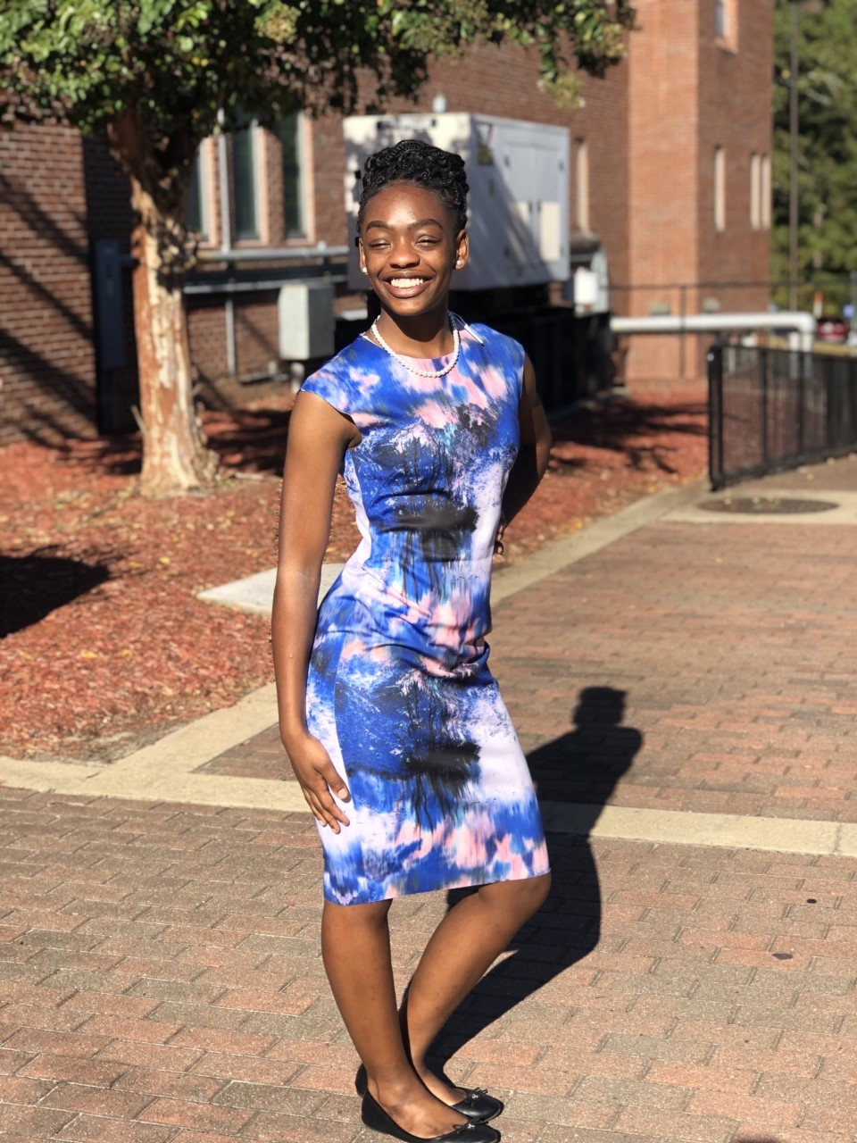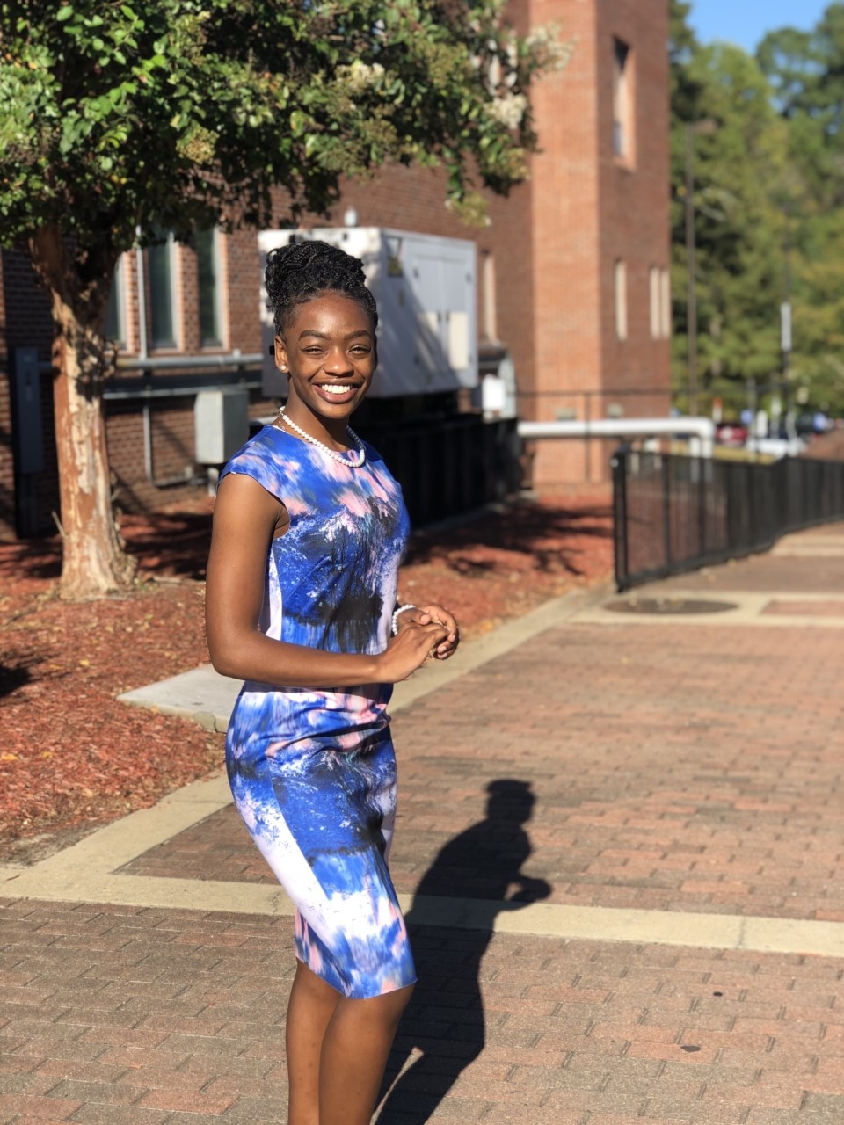

Submission 18
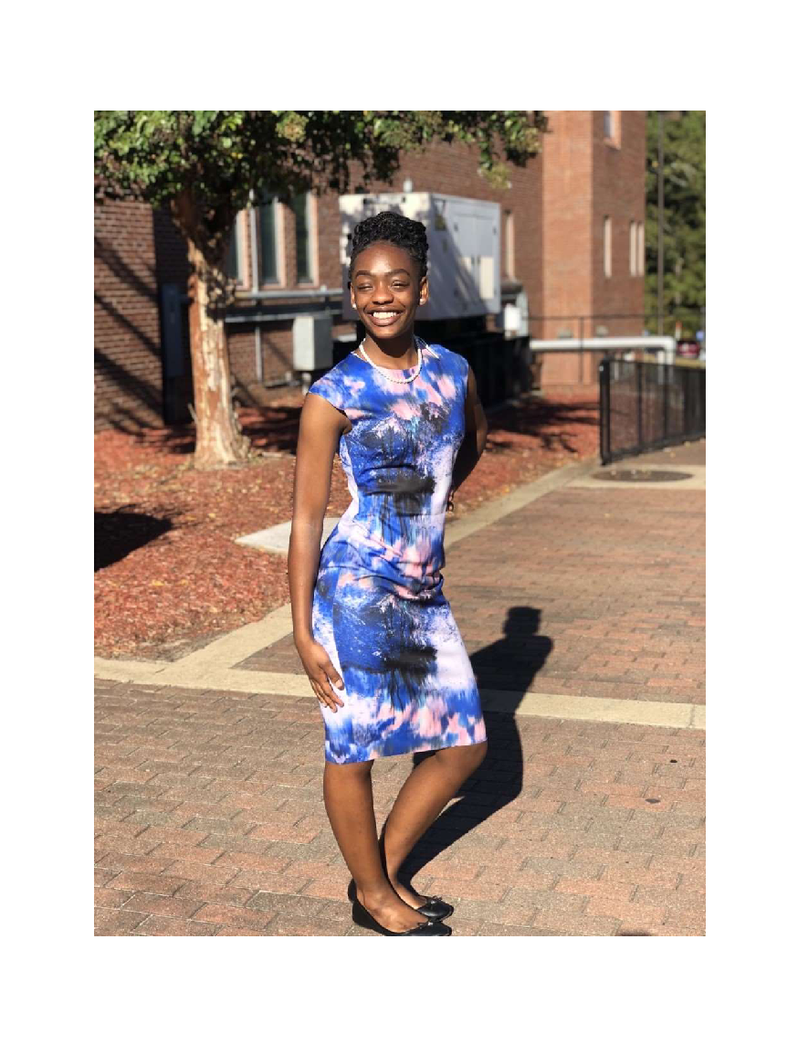
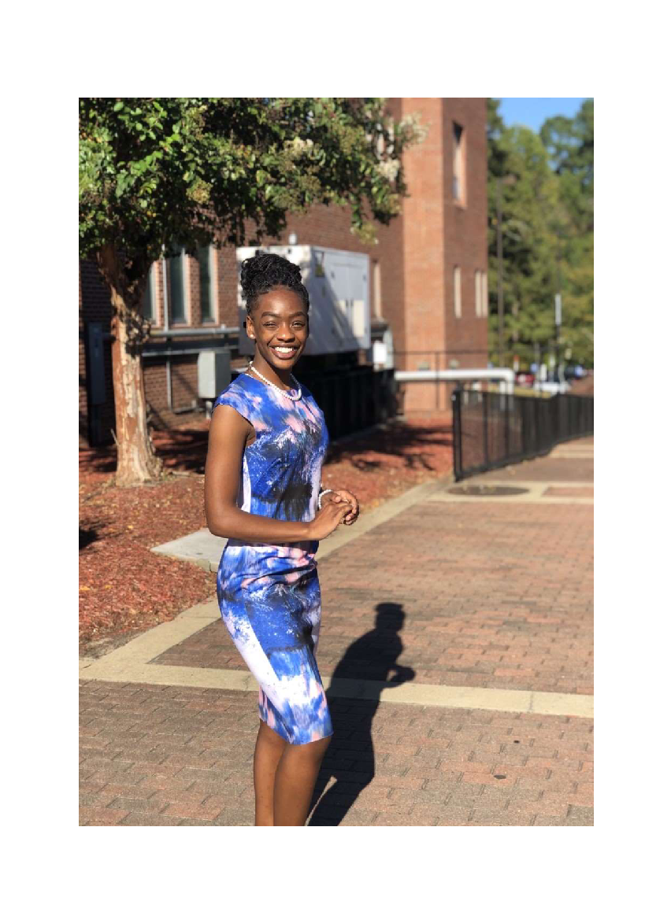
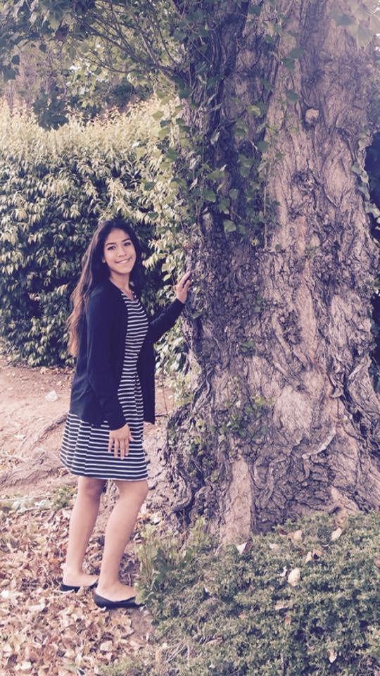
Caption "I am a student with autism spectrum disorder, I find the outdoors to be comforting and soothing as I do experience sensory overload."

Submission 19

Through a dark cloud comes the silver lining, hope, & success
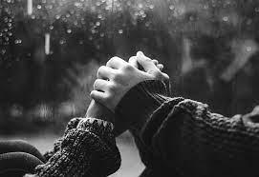
The moments when peers or teachers reach out to you with an offer of support gives your heart a sense of belonging

At the end of the day, it is not the disability that defines you. It is your shine, compassion, drive, and love for life. Some of us were put on earth to share ❤️ with all living things. The most important thing to remember: Where there is a will, there is a way! With a little bit of aspiration, faith, and discipline you can make your dreams come true Reine
Submission 20

Click the hyperlink below to access the “Give Me a Reason” video:

https://drive.google.com/file/d/1-X_z4EIqm_x-KBXQKwbEa2f4Coxlu_cs/view?usp=share_link

