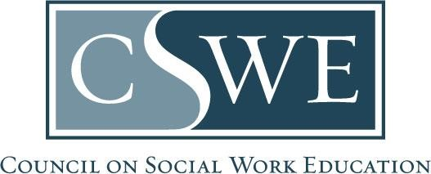

Board of Accreditation (BOA)
Department of Social Work Accreditation (DOSWA)
Baccalaureate and Master’s Social Work Program Accreditation

2022 EPAS
Temporary Extension Request Form | 2022 EPAS Implementation

Purpose
- In extenuating circumstances, this temporary extension permits programs to request a 1-year shift from July 1, 2025 to July 1, 2026 for their 2022 EPAS implementation date.
- The purpose of this temporary waiver is to permit an additional year for intentional planning and transition efforts to implement the 2022 EPAS by July 1, 2026.
- This is a one-time only request.
- Programs must provide a clear rationale.
- This does not permit the program’s next reaffirmation review to be under the 2015 EPAS.

Eligibility
- Baccalaureate or master’s social work programs post-initial accreditation or between reaffirmation review cycles.

Formatting & Submission
- Submit this form as a Microsoft Word document or searchable PDF, per policy 4.7 Document Formatting & Submission Requirements in the Accreditation Policy Handbook.
- Scanned documents will not be accepted.
- Email completed forms to the Director of Accreditation Services.

Timeframe for Review & Response
Forms are reviewed and processed within two (2) weeks of receipt. Programs will receive a temporary extension approval letter.

Date Submitted to CSWE’s Department of Social Work Accreditation | MM/DD/YYYY

Program Information

Name of Educational Institution:
Program State, District, or Territory:
Program Level: | ☐ Baccalaureate  ☐ Master’s
Next Accreditation Review Date:

Must match CSWE records; review Directory of Accredited Programs for accuracy
Next Accreditation Review Type: | ☐ Initial Accreditation  ☐ Reaffirmation

Rationale for the Request:

Insert a brief rationale for requesting this temporary extension

Form Authorization

By submitting this form, the program acknowledges:
(check each box)

☐ As described in our rationale, we affirm extenuating circumstances are preventing the program from transitioning to the 2022 EPAS by July 1, 2025 in accordance with the 2022 EPAS implementation timeline.

☐ We affirm that the program will remain complaint with all 2015 EPAS standards including Accreditation Standard 3.0 Diversity as well as Competency 2: Engage Diversity and Difference in Practice and Competency 3: Advance Human Rights and Social, Economic, and Environmental Justice.

☐ We understand this temporary extension is a one-time only 1-year shift from July 1, 2025 to July 1, 2026.

☐ We understand this temporary extension does not permit the program’s next reaffirmation review to be under the 2015 EPAS.

☐ We understand that the temporary waiver expires July 1, 2026.

☐ We agree to continue planning and transition efforts to implement the 2022 EPAS by July 1, 2026.

☐ We understand the conditions of this temporary extension.

Primary Contact  Signature: | Insert e-signature or image of signature
Primary Contact
Name, Credentials:

Must match CSWE records; review Directory of Accredited Programs for accuracy
Title:
Business Phone Number: | (###) ###-####
Business Email Address:

The primary contact’s role is described in policy 4.1 Primary Contact & Accreditation Communications in the Accreditation Policy Handbook. The primary contact manages all accreditation-related communications between the program and CSWE.

